**Twinkle, Twinkle Little Star**

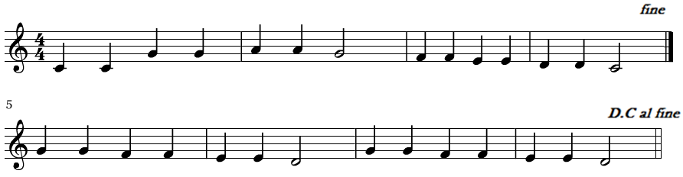

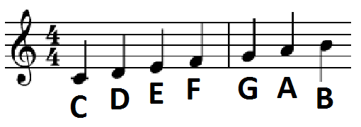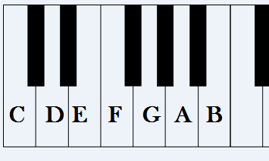

1 Thumb 2 3 4 5 stretch

Pinky