Name: _________________________________ Homeroom: __________
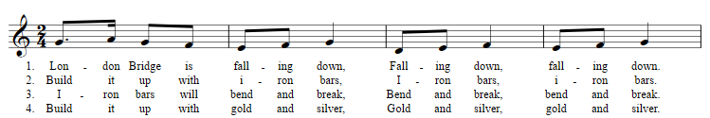
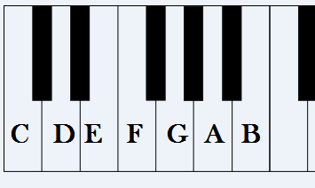
1 Thumb 2 3 4 5 5
stretch
Pinky

