GCES Choir Shirt Order Form
This is the design that the majority of our choir members chose. The color is “Cardinal” and looks like a dark red/burgandy.

If in need of financial assistance, please fill out and turn in the form and leave me a note. I completely understand that some may need extra time or help.

Please let me know if you have questions!
Mrs. Brooke Bowling
bbowling@cpcsc.k12.in.us

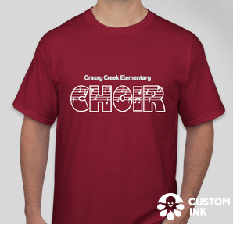

Student Name:

Shirt Size (circle one):

Child Med. Child Large Child XL

Adult Small Adult Med. Adult Large Adult XL Adult 2XL

Please submit form and $9.20 payment by:
Tuesday, November 26th
- I am paying cash.

- I am paying with check # _______ made out to Grassy Creek Elementary.

- I need more time to send in payment/financial assistance.
____________________________________________________________________________________________________________

