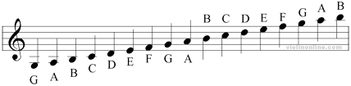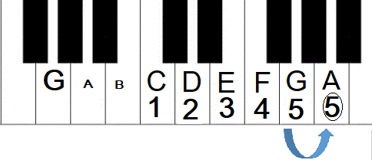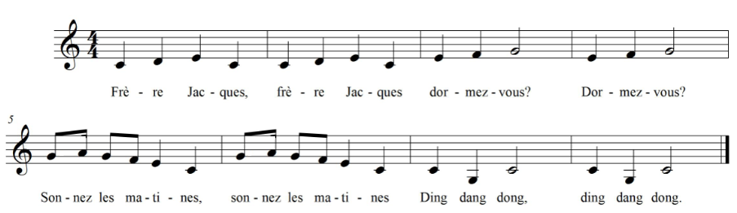

**Frere Jacques in C Major**

**Name: _____________________________________________ Teacher: _____________________**