Whole Note  4 beats | Half Note  2 beats | Quarter Note  1 beat | Two Eighth Notes  1 beat  (1 eighth rest would be ½ beat) | Four Sixteenth Notes  1 beat
Whole Rest  4 beats | Half Rest  2 beats | Quarter Rest  1 beat | Eighth Rest  ½ beat  (2 eighth rests would equal 1 beat) | Sixteenth Rest  ¼ beat  (Four sixteenth rests would equal 1 beat)
Repeat Sign: Means do that section again | Double Bar Line: Means the end of the music | Time Signature: Tells you how many beats in a measure + | Staff: The five lines that you draw music on | Da Capo al fine: Means go back to the beginning and end at the word fine (end)

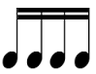 | 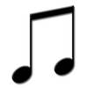 | 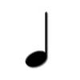 | 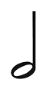
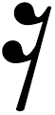 | 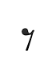
D.C al fine |  | 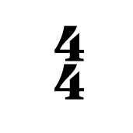 |  | 