September 7, 2017

Dear parents and guardians,

I am sending the recorders home this week so that kids will get a chance to practice covering the holes to get a good sound. We have had the recorder for at least four classes, so my hope is that giving them time to practice on their own will help them fix problems and build their confidence.

Please remind your child to/that:
- Use the left hand on top, right hand on bottom.
- Use slow warm air.
- Cover the holes completely.
- If there is a squeak, they are blowing too hard, or not covering a hole completely. 95% of the time it is because the holes are not completely covered.
- If the sticker name tag comes off, please feel free to use a permanent marker to put their name on the recorder.
- Not play the recorder in the car or on the bus.
- The goal is get a clear sound and be able to play the White Belt page.
- RECORDERS MUST COME BACK FOR THE NEXT MUSIC CLASS!

The songs for the first belt only include two notes, G and E. Mastering the songs on the white belt page is a Level 1 and a White Belt (I use colored rubber bands to represent the recorder karate belts—white-level 1, yellow-level 2, orange-level 2, green-level 2, blue-level 3, and purple-level 4). The goal is for kids to be able to read the music while playing the recorder, not just memorize a song. More information on this later.

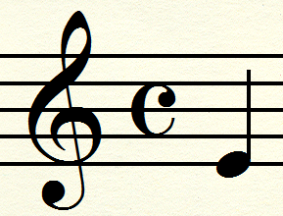
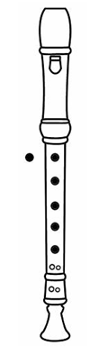
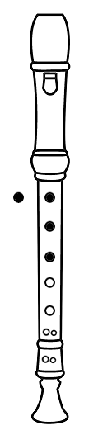
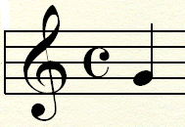
Mrs. Brooke Bowling
Music Teacher
bbowling@cpcsc.k12.in.us
(317) 535-3980
http://music-bowling.weebly.com/

Every

Every

Good

